The Central Library and Digital Resource Centre have books, journals, volumes related to all branches of science, engineering, and management. It is fully automated using integrated library management system Linways. The library has well developed infrastructure and has a built up area of 1000 sq.m. In addition to the central library, departmental libraries cater to the resources pertaining to specialised knowledge areas. Located in the main building, the resources of the library are open to all the departments of the institute.

The library also maintains a balanced collection of books for general reading and references. At present the collection exceeds 45,000 inclusive of several reference books, project reports and back volumes of periodicals.. The Library provides access to around 78 print journals, J-Gate Access journals full text(42488 numbers), DELNET (816 e-books & 913 journals). The academic community of RIET can access e-books, theses database, journal database, e-journals and other e-resources from any terminal in the campus. Members can avail themselves of the services of DELNET, NDL Digital Library Network and IEI Library Network.

RIET is also a member of APJKTU- Digital Library Consortium (298 journals-Elsevier). RIET Library is having memberships in Institution of Engineers India - Springer and E Shodhsindhu.

CCTV cameras are installed in the library for surveillance purposes.

APJ AKTU Digital Library Consortium(Elsevier Journal Database & Knimbus Platform)

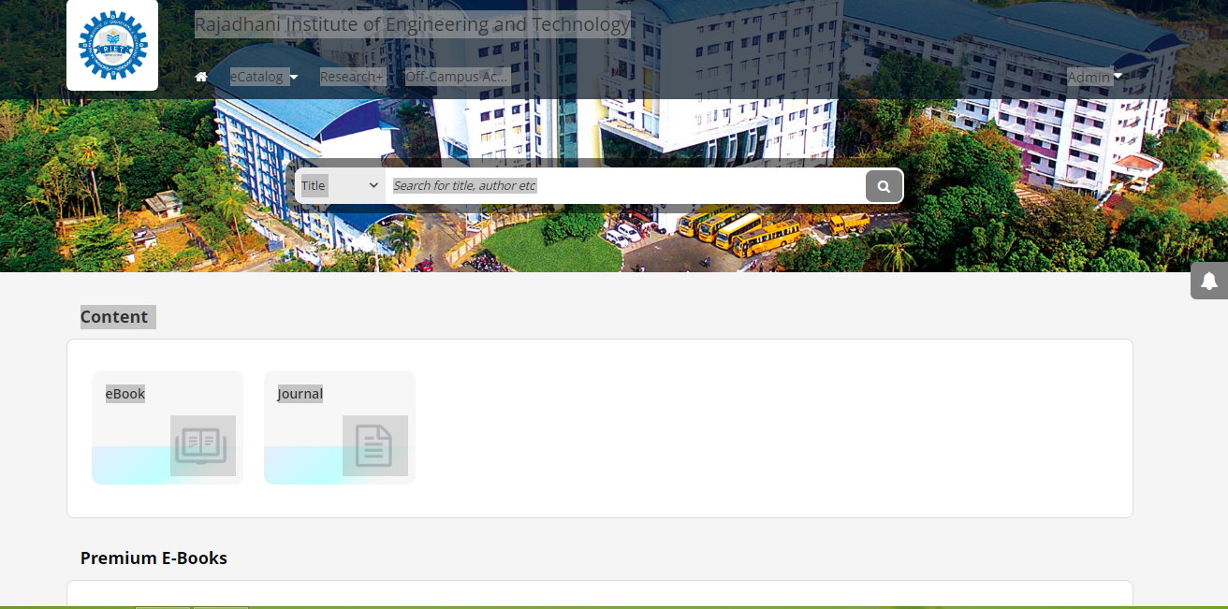

DELNET

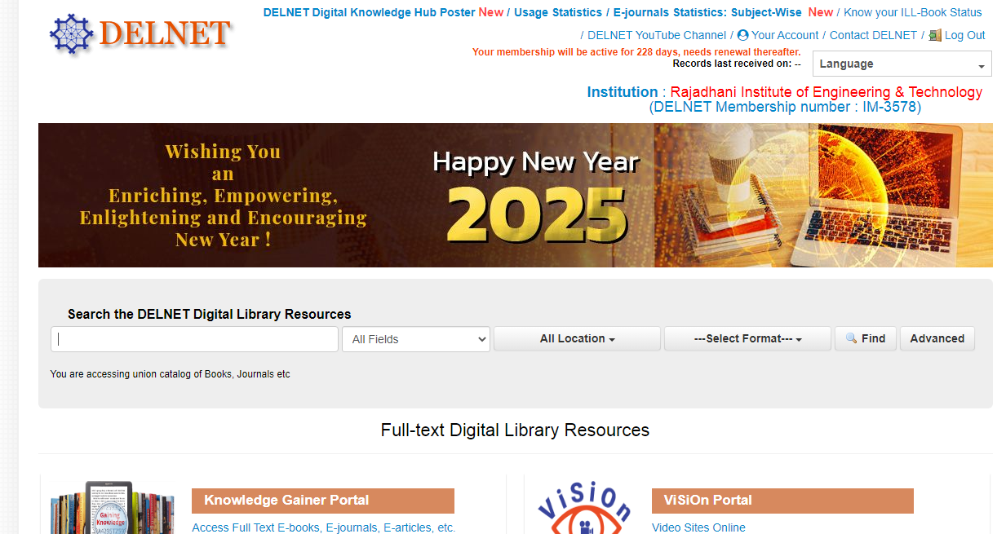

J-Gate

